Function words

📘 What Are Function Words?
# Source: AI Source: Provided by: [Data Path: Persons Table -> ID Column: 1, Name_En Column: Motasem Essam] -> From: [Chatgpt (GPT-4-turbo)] on [7/24/2025]
Function words are words that do not carry much lexical meaning but are essential for grammatical structure.
They help us build correct and meaningful sentences by connecting, modifying, or specifying content words.

🧠 Main Categories of Function Words:
# Source: AI Source: Provided by: [Data Path: Persons Table -> ID Column: 1, Name_En Column: Motasem Essam] -> From: [Chatgpt (GPT-4-turbo)] on [7/24/2025]
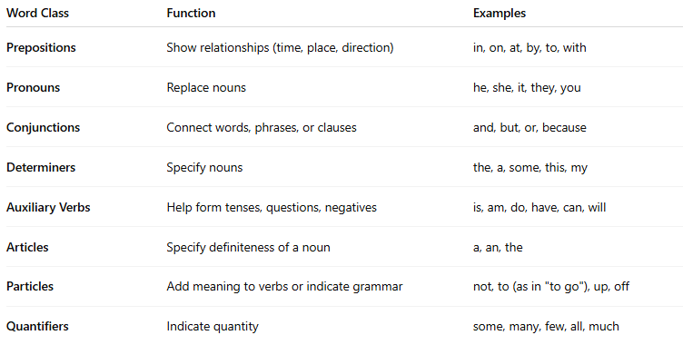
Word Class | Function | Examples
Prepositions | Show relationships (time, place, direction) | in, on, at, by, to, with
Pronouns | Replace nouns | he, she, it, they, you
Conjunctions | Connect words, phrases, or clauses | and, but, or, because
Determiners | Specify nouns | the, a, some, this, my
Auxiliary Verbs | Help form tenses, questions, negatives | is, am, do, have, can, will
Articles | Specify definiteness of a noun | a, an, the
Particles | Add meaning to verbs or indicate grammar | not, to (as in "to go"), up, off
Quantifiers | Indicate quantity | some, many, few, all, much

✳️ Key Characteristics of Function Words:
# Source: AI Source: Provided by: [Data Path: Persons Table -> ID Column: 1, Name_En Column: Motasem Essam] -> From: [Chatgpt (GPT-4-turbo)] on [7/24/2025]
- Carry little or no standalone meaning
- Used for grammar, not content
- Belong to a closed class (rarely accept new words)
- Often unstressed in speech
- Cannot usually stand alone as meaningful answers

✅ Examples in Sentences:
# Source: AI Source: Provided by: [Data Path: Persons Table -> ID Column: 1, Name_En Column: Motasem Essam] -> From: [Chatgpt (GPT-4-turbo)] on [7/24/2025]
- She is at the park.
→ she (pronoun), is (auxiliary), at (preposition), the (article) = function words
- I will go if you come.
→ I, will, if, you = function words
- This is my book.
→ this, is, my = function words

🆚 Function Words vs Content Words
# Source: AI Source: Provided by: [Data Path: Persons Table -> ID Column: 1, Name_En Column: Motasem Essam] -> From: [Chatgpt (GPT-4-turbo)] on [7/24/2025]
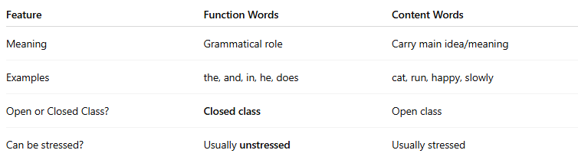
Feature | Function Words | Content Words
Meaning | Grammatical role | Carry main idea/meaning
Examples | the, and, in, he, does | cat, run, happy, slowly
Open or Closed Class? | Closed class | Open class
Can be stressed? | Usually unstressed | Usually stressed

✅ Summary:
# Source: AI Source: Provided by: [Data Path: Persons Table -> ID Column: 1, Name_En Column: Motasem Essam] -> From: [Chatgpt (GPT-4-turbo)] on [7/24/2025]
Function words are the grammar tools of language.
They help link, modify, or clarify content words and form the structure of sentences.

